
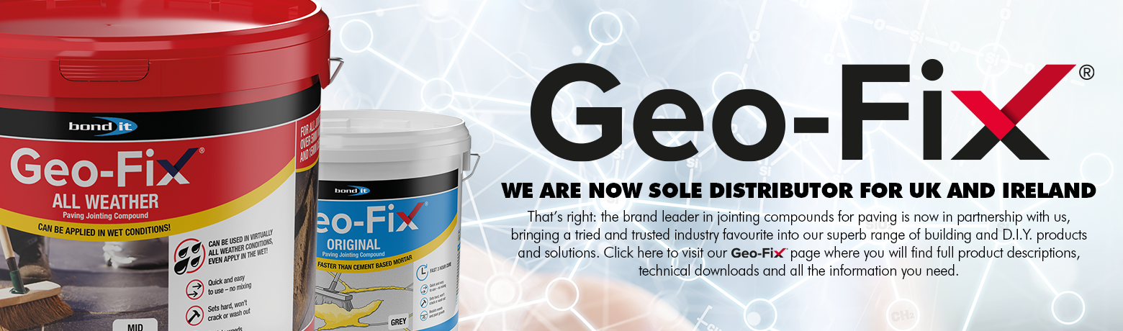

GEO-FIX® USPs
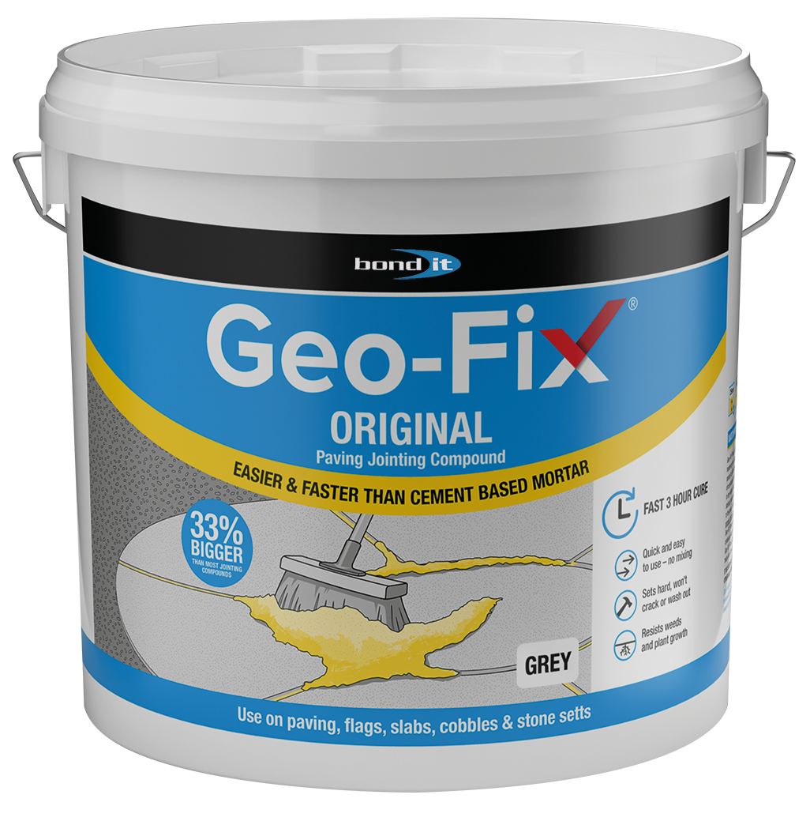
ORIGINAL
- Cost effective – bigger tubs, more for your money.
- Vacuum packed in extra strong 128 micron sealed foils for freshness. Removes oxygen, bacteria and preserves shelf life.
- Superior strength to competitors – flexural and compressive.
- Great export product for dry climates, (cold or warm).
- Indoor or outdoor use.
- Can be used in temperatures below freezing.
- Rapid setting, fast drying.
- None staining if residue swept away.
- Fastest curing product on the market – 2 ¹/₂ hours at 20⁰C – (competitors typically 6 – 12 hours – up to several days!).
- Proven Track record – Original polymeric jointing sand - 25 years use in market.
- Freeze thaw exceeds BCRL:BM2:1993 – exceeds 100 cycles.
- Non staining – no need to use water to protect the paving from polymer staining.
- A permeable bed is not required as long as suitable falls are incorporated into the sub-base to allow water to drain away
- Long lasting and durable.
- Size: 20Kg.
- Colours: buff and grey.

ALL WEATHER
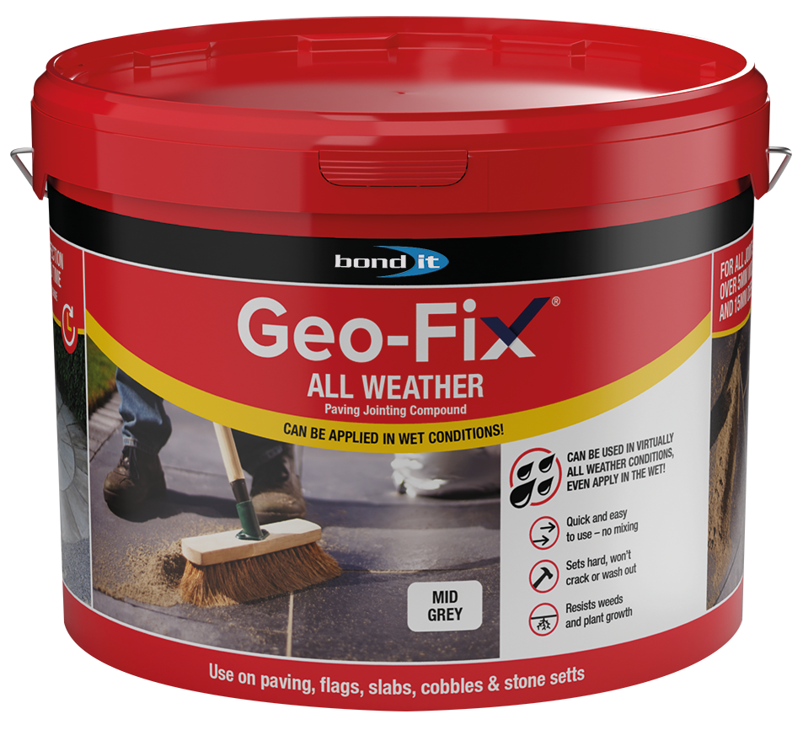
- Vacuum packed in extra strong 128 micron sealed foils for freshness. Removes oxygen, bacteria and preserves shelf life.
- A Hydrophobic product which totally repels water.
- Fast Curing time when allowed to dry 4 – 12 hours.
- Colour fast sands to produce consistent colour. No pigments used.
- Minimum depth 15mm which suits most types of concrete, ceramic, porcelain and natural stone paving, (other products min 20-25mm).
- When laying porcelain tiles, that are generally a minimum thickness of 20mm, migration of the mortar bed and base slurry coat will impact on the joint depth and often lead to jointing compounds popping out as they require a full 20mm clearance. Geo-Fix, All Weather has been designed for use in joints down to 15mm deep, therefore will not be compromised in this situation.
- Geo-Fix Track Record.
- Freeze Thaw DD/CEN/TS 772:22:2006 exceeds 100 cycles representing the most severe conditions which the product was likely to be subjected to.
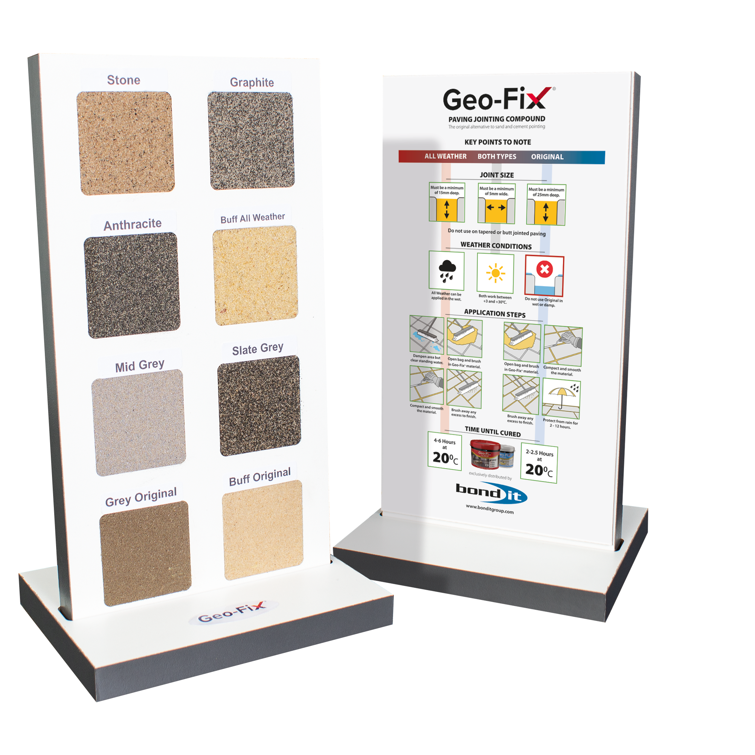
- Works in all weather conditions – making this a product that can be used 365 days of the year.
- A permeable bed is not required as long as suitable falls are incorporated into the sub-base to allow water to drain away
- Long lasting and durable.
- Size: 14Kg.
- Colours: Anthracite, graphite, stone, mid grey, slate grey and buff.


